



Functional Specification for HSBC and SCB Integration

Prepared for: | Gold Coin SkyShift
Prepared by: | Fortude
Project: | HSBC and SCB Integration
QMS No: | FTD_M3_FS 1968

This document has been prepared by Fortude (Pvt) Ltd. and is not to be distributed, copied or reproduced without permission.
© 2026 Fortude (Pvt) Ltd. All rights reserved.

Table of Contents
1. Introduction 5
1.1. Purpose 5
1.2. Document Version Control 5
1.3. Definitions and Abbreviations 5
2. Scope 7
2.1. SCOPE INCLUSIONS 7
2.1.1. Supplier Banking Validation During Invoice Creation (APS100) 7
2.1.2. Banking Method Auto-Selection During Payment Proposal (APS130 / APS131) 7
2.1.3. Payment Confirmation Trigger via APS161PF 8
2.1.4. MBM 500 Message Generation 8
2.1.5. MEC Outbound XML Transformation 9
2.1.6. XML File Drop to EC Server Location 9
2.1.7. PowerShell-Based Secure File Transfer to Bank 10
2.1.8. Bank Acknowledgment (ACK) File Handling – Inbound XML 10
2.1.9. ION and IDM Email Distribution 11
2.2. Excluded 11
2.2.1. Manual Payment Processing 11
2.2.2. Bank Portal Uploads 11
2.2.3. Non-Listed Country Integrations 11
2.2.4. Treasury or External Payment System Integration 12
2.2.5. Supplier Master Data Maintenance 12
2.3. The main workflow 12
3. Functional Specification 14
3.1. Requirement/functionality 14
3.1.1. User Story 14
3.1.2. Workflow 15
3.2. ISO 20022 Compliance Updates for HSBC Integration only 16
3.2.1. Postal Address Requirements 16
3.2.2. SWIFT/BIC Validation Requirements 17
3.2.3. Unstructured Remittance Information (Ustrd) 17
3.3. Component wise Technical details 21
3.3.2. Test cases and results 24
4. Non-functional Specifications (NFRs) 25
5. Assumptions and Dependencies 26
6. Environment 27
7. Additional Information 28

List of Tables
Table 1: User Story 6
Table 2Test Cases: 8

Table of figures
Figure 1: Workflow Name 5
Figure 2: Workflow Name 6

- Introduction
This document describes the functional and technical specification for the banking integration between Infor M3 and external banking partners for electronic supplier payments.
The integration covers:
- HSBC – Malaysia, Indonesia, Vietnam, Singapore divisions
- Standard Chartered Bank (SCB) – China division
The integration enables automated outbound payment file generation and inbound bank acknowledgment processing through MEC, ION, and IDM.
  - Purpose
The purpose of this document is to:
- Define the end-to-end payment integration workflow from invoice creation to bank acknowledgment.
- Document all validation JavaScripts used in:
  - APS100 (Invoice validation)
  - APS131 (Banking method selection during proposal creation)
- Define outbound and inbound XML structures per country-bank combination.
- Provide clarity for testing, audit, and future enhancements.
- Serve as a reference for support and regional rollout.

  - Document Version Control
Version | Date | Description | Author
V1.0 | 20251105 | Cloud Uplift Skyshift | Safwan A
V2.0 | 20260919 | HSBC ISO20022 Updates | Safwan A

  - Definitions and Abbreviations
Term | Description
M3 | Infor M3 ERP system
APS100 | Supplier Invoice Entry
APS130 | Payment Proposal Creation
APS131 | Payment Proposal – Detail Panel
APS161PF | Payment Confirmation Print File
MBM 500 | M3 Business Message for Payment Trigger
ION | Infor Intelligent Open Network
IDM | Infor Document Management
EC Server | Enterprise Collaborator server
XML | Extensible Markup Language
ACK | Bank Acknowledgment File

- Scope
  - SCOPE INCLUSIONS
This section defines the detailed functional and technical components that are covered under the banking integration between Infor M3 and the external banks, namely HSBC (Malaysia, Indonesia, Vietnam, Singapore) and Standard Chartered Bank (China).

    - Supplier Banking Validation During Invoice Creation (APS100)
The solution includes automated validation of supplier banking information at the point of invoice entry within APS100 to ensure payment readiness and prevent downstream payment rejections.
Detailed coverage:
- Validation of payment method defined in CRS945 against supplier master.
- Verification that mandatory banking fields are populated, including:
  - Bank account number
  - Bank code / clearing code (country-specific)
  - SWIFT/BIC (for international payments)
  - IBAN (where applicable)
  - Beneficiary name consistency (if configured)
- Script-based validation logic executed during invoice entry and update.
- Blocking mechanism to prevent invoice approval if mandatory banking details are missing or invalid.
- Country-specific validation rules aligned with HSBC (MY, ID, VN, SG) and SCB (CN) payment format requirements.
    - Banking Method Auto-Selection During Payment Proposal (APS130 / APS131)
The scope includes automated determination and assignment of the correct banking method during payment proposal creation.
Detailed coverage:
- Execution of custom JavaScript in APS131 panel during proposal generation.
- Logic to derive banking method based on:
  - Supplier country
  - Division / company
  - Payment method configuration (CRS945)
  - Bank mapping rules
  - Currency and payment type (local vs cross-border)
- Prevention of manual misselection of bank formats.
- Consistent assignment of bank-specific payment codes for:
  - HSBC Malaysia, Indonesia, Vietnam, Singapore
  - SCB China
- Support for scheduled and manual APS130 proposal runs.

    - Payment Confirmation Trigger via APS161PF
The integration includes automated triggering of downstream integration events upon payment proposal confirmation.
Detailed coverage:
- Generation of APS161PF print file upon proposal confirmation.
- Use of APS161PF as the formal trigger document for bank file generation.
- Ensuring only confirmed proposals initiate bank file processing.
- Control to avoid duplicate file generation for the same payment batch.

    - MBM 500 Message Generation
The scope includes the creation and utilization of M3 Business Message (MBM 500) as the integration trigger.
Detailed coverage:
- Automatic generation of MBM document 500 from APS161PF.
- Inclusion of key payment data:
  - Supplier details
  - Payment amount
  - Currency
  - Bank method
  - Payment date
  - Proposal number
- Reliable event-based integration architecture using MBM as the source message.
- Logging and traceability of MBM transactions for audit purposes.
    - MEC Outbound XML Transformation
The solution covers transformation of MBM 500 messages into bank-compliant XML formats via MEC.
Detailed coverage:
- Message pickup from M3 by MEC (M3 Enterprise Collaborator).
- Country and bank-specific XML mapping configurations.
- Separate XML structure handling for:
  - HSBC Malaysia
  - HSBC Indonesia
  - HSBC Vietnam
  - HSBC Singapore
  - SCB China
- Data transformation, field mapping, and format validation.
- Encoding and schema compliance as per bank specifications.
- Error handling and reprocessing capability within MEC.
    - XML File Drop to EC Server Location
The integration includes controlled file output to the designated Enterprise Collaborator (EC) server directory.
Detailed coverage:
- Automatic placement of generated outbound XML files into secured EC outbound folders.
- Structured file naming conventions (e.g., Division, Date, Proposal ID).
- Environment segregation (TEST vs PROD).
- File integrity checks prior to transfer.
- Access-controlled directory management for security and audit compliance.

    - PowerShell-Based Secure File Transfer to Bank
The scope includes automated transmission of payment XML files from the EC server to the respective bank endpoints.
Detailed coverage:
- Scheduled or event-driven PowerShell scripts monitoring outbound directories.
- Secure file transfer mechanism (e.g., SFTP or bank-secured channel).
- Bank-specific routing logic based on division and payment method.
- Transfer logging including:
  - Timestamp
  - File name
  - Transfer status (Success/Failure)
- Retry mechanism in case of transmission failure.
- Encryption and secure credential handling as per IT security standards.

    - Bank Acknowledgment (ACK) File Handling – Inbound XML
The integration includes automated receipt and processing of bank acknowledgment files.
Detailed coverage:
- Receipt of acknowledgment XML files from HSBC and SCB into EC inbound directory.
- MEC inbound processing and parsing of ACK files.
- Validation of:
  - File status (Accepted/Rejected)
  - Error codes (if any)
  - Reference to original payment file or batch
- Update of internal tracking/log tables where applicable.
- Storage of acknowledgment documents for audit and reconciliation.

    - ION and IDM Email Distribution
The scope includes automated notification and document distribution using ION workflows and IDM.
Detailed coverage:
- Triggering of ION document flow upon successful inbound ACK processing.
- Attachment storage in IDM for:
  - Outbound payment XML
  - Inbound acknowledgment XML
- Automated email notifications to finance/treasury stakeholders.
- Configurable email rules based on:
  - Success acknowledgment
  - Rejection or error acknowledgment
  - Missing acknowledgment within defined SLA
- Centralized document traceability for audit and compliance.
  - Excluded
    - Manual Payment Processing
- Manual payment runs outside APS130/APS131 workflow are not covered.
- Offline or ad-hoc payment file generation is excluded from this integration scope.
    - Bank Portal Uploads
- Manual upload of payment files through bank web portals is not included.
- The solution strictly supports automated system-to-bank file transmission only.
    - Non-Listed Country Integrations
- Integrations with banks outside:
  - HSBC (MY, ID, VN, SG)
  - SCB (China)
are excluded from this specification.
- Future country rollouts will require separate design and mapping documents.

    - Treasury or External Payment System Integration
- No integration with Treasury Management Systems (TMS).
- No integration with external payment hubs or third-party payment gateways.
- The scope is limited to direct M3 → MEC → Bank architecture.
    - Supplier Master Data Maintenance
- Creation or maintenance of supplier banking details in master data (CRS620/CRS624) is considered a business process and not part of the integration logic scope.
- The system only validates existing data; it does not enrich or auto-create banking records.

  - The main workflow
Step 1 – Invoice Creation (APS100)
- Supplier invoice is created in APS100.
- JavaScript validation checks:
  - Payment method defined in CRS945
  - Supplier master banking details exist
  - Bank account number
  - SWIFT/BIC (if required per country)
  - IBAN (if applicable)
- Invoice cannot be approved if validation fails.
Step 2 – Payment Proposal Creation (APS130)
- Payment proposal created as per scheduled run.
- In APS131 panel:
  - JavaScript determines correct banking method.
  - Logic based on:
    - Supplier country
    - Division
    - Payment method
    - Bank mapping rules
Step 3 – Payment Confirmation
- Proposal confirmed.
- APS161PF document is generated.
- APS161PF triggers MBM document 500.
- MBM 500 picked up by MEC.
Step 4 – Outbound XML Creation
MEC performs:
- Transformation of MBM 500 into bank-specific XML format.
- Country-specific XML mapping:
  - HSBC MY
  - HSBC ID
  - HSBC VN
  - HSBC SG
  - SCB CN
XML is dropped to: EC Server outbound directory

Step 5 – Bank Transfer
- PowerShell script monitors EC outbound folder.
- XML file is securely transferred to bank server.
- Bank processes payment file.
Step 6 – Inbound Acknowledgment
- Bank sends acknowledgment XML.
- File received in EC inbound directory.
- MEC processes inbound XML.
- Status updated in M3 (if applicable).
- ION triggers workflow.
- IDM attaches document.
- Email notification sent to stakeholders.

- Functional Specification

  - Requirement/functionality
Explain the specific requirement or functionality.
    - User Story
Reference ID | Description | Priority
001 | Validate supplier banking details during invoice entry. | Must have
002 | Set banking method during proposal. | Must have
003 | Generate country-specific outbound XML. | Must have
004 | Securely transfer file to bank. | Must have
005 | Process bank acknowledgment XML. | Must have
006 | Notify users via email through ION/IDM. | Must have
Table 1: User Story

    - Workflow

Invoice Entry (APS100)
↓
Bank Validation Script
↓
Payment Proposal (APS130)
↓
Bank Method Selection Script (APS131)
↓
Proposal Confirmation
↓
APS161PF
↓
MBM 500
↓
MEC Transformation
↓
Outbound XML
↓
PowerShell Transfer
↓
Bank
↓
Acknowledgment XML
↓
MEC Inbound
↓
ION Workflow
↓
IDM Email Notification

  - ISO 20022 Compliance Updates for HSBC Integration only
As part of the ISO 20022 migration requirements for the existing HSBC payment integration, updates are required to ensure that payment files generated from M3 comply with the data validation and formatting requirements applicable to HSBC.

The existing HSBC payment integration and processing flow remain unchanged. The changes described in this section are limited to the data requirements and validations required to support ISO 20022 compliance.

HSBC has introduced requirements for structured and hybrid postal addresses. For Priority Payments, Town Name and Country must be provided at minimum, with structured or hybrid address formats becoming mandatory from November 2026.

    - Postal Address Requirements
The existing HSBC payment file generation must be updated to ensure that the postal address information for both the Debtor and Creditor contains, at minimum, the following fields:
Field | Requirement
Town Name | Mandatory
Country | Mandatory

This requirement is covered under the HSBC APS100 Banking Invoice Verification H5 Script, as detailed in Section 3.3.1.1.
The address may be supplied using a structured or hybrid format. Under the hybrid format, Town Name and Country are provided as structured fields, while additional address information can continue to be provided through Address Line.
The following ISO 20022 structure illustrates the required information:
<PstlAdr>
<PstCd>1000</PstCd>
<TwnNm>BRUSSELS</TwnNm>
<Ctry>BE</Ctry>
<AdrLine>HOOGSTRAAT 6</AdrLine>
</PstlAdr>

Requirement:
- Debtor Postal Address – Town Name and Country must be populated.
- Creditor Postal Address – Town Name and Country must be populated.
- Existing address information should continue to be passed where available.
- The implementation should support the HSBC-required structured/hybrid address format.
HSBC has advised that after November 2026, Priority Payment instructions will only be processed using either a structured or hybrid address format.

    - SWIFT/BIC Validation Requirements
The BIC (Bank Identifier Code), commonly referred to as the SWIFT/BIC code, included in the HSBC payment file must comply with the applicable ISO 20022 BIC format requirements.
BIC validation must be performed during the payment file generation process to prevent invalid BIC values from being transmitted to HSBC.
ISO BIC Format:
A BIC must contain 8 or 11 characters and follow the following format:
AAAA BB CC DDD
Where:
- AAAA – 4-character bank/institution code
- BB – 2-character country code
- CC – 2-character location code
- DDD – Optional 3-character branch code (XXX Dummy codes are not allowed)

Accordingly, the BIC must conform to the following format:
[A-Z]{6}[A-Z0-9]{2}([A-Z0-9]{3})?
The existing banking master and payment data must be reviewed to ensure that all BIC values used by the HSBC integration conform to the above format.
BIC/SWIFT codes are maintained in M3 as part of the Bank Account Master Data through program CRS692.
    - Unstructured Remittance Information (Ustrd)
The Ustrd field is used to provide payment purpose and invoice information associated with the payment.
The following format should be used:
invoice1(invoice1_amount)invoice2(invoice2_amount)
- invoice_number(invoice_amount) = Invoice number followed by the corresponding invoice amount.
- invoice is free-format and may contain alphanumeric characters and symbols.
- invoice_amount must contain numerical characters only.

XML v3.0 Mapping
The information will be populated under:
<CdtTrfTxInf>
...
<RmtInf>
<Ustrd>...</Ustrd>
<Ustrd>...</Ustrd>
...
</RmtInf>
</CdtTrfTxInf>

Rules:

- Each Ustrd field must not exceed 105 characters, including the 2012// purpose code where applicable.
- Invoice information must not be split in the middle of an invoice number or invoice amount.
- Where the complete invoice information cannot fit within the available 105-character limit, the complete invoice information must be moved to the next Ustrd field within the same <RmtInf> element.
- Multiple <Ustrd> fields must remain under the same <RmtInf> tagging for the payment transaction.
- The + sign must be used where required to indicate that additional invoice information continues in the subsequent message/field, in accordance with the existing HSBC format.
- The slash ( / ) character must not be used at the 36th or 71st character position.
- The system must ensure that the invoice number and corresponding invoice amount remain together. The invoice amount must not be separated from its invoice number due to the character limit.
- Where the complete invoice information cannot be accommodated within the available Ustrd fields, the remaining information must be provided through the applicable supplementary/manual message process.

Sample 1 – All Invoice Information Fits
Where the complete invoice information fits within the available character limit:
<CdtTrfTxInf>
...
<RmtInf> <Ustrd>2012//invoice1(invoice1_amnt)invoice2(invoice2_amnt)invoice3(invoice3_amnt)invoice4(invoice4_amnt)</Ustrd>
</RmtInf>
</CdtTrfTxInf>

Sample 2 – Invoice Information Continues
Where the complete invoice information exceeds the available character limit, the invoice information must be continued without cutting an invoice/amount combination.
<CdtTrfTxInf>
...
<RmtInf>
<Ustrd>2012//invoice1(invoice1_amnt)invoice2(invoice2_amnt)invoice3(invoice3_amnt)invoice4(invoice4_amnt)+</Ustrd>
<Ustrd>invoice5(invoice5_amnt)invoice6(invoice6_amnt)invoice7(invoice7_amnt)invoice8(invoice8_amnt)</Ustrd>
</RmtInf>
</CdtTrfTxInf>

Sample 3 – Group Invoice
Where the payment represents a single group invoice covering the total transfer amount:
<CdtTrfTxInf>
...
<RmtInf>
<Ustrd>2012//group-invoice(invoice1_amnt)</Ustrd>
</RmtInf>
</CdtTrfTxInf>
The system must:
- Generate the required 2012// purpose code where applicable. (Not Applicable)
- Append invoice number and invoice amount pairs sequentially.
- Calculate the character length before generating each Ustrd.
- Start a new Ustrd field when adding the next complete invoice would exceed the 105-character limit.
- Never split an invoice number or invoice amount between two Ustrd fields.
- Maintain all Ustrd fields under the same <RmtInf> element.
- Apply the + continuation indicator where required.
- Ensure the resulting XML remains compliant with the HSBC ISO 20022 payment file requirements.

  - Component wise Technical details

APS100 Banking invoice verification

Country | Document | Component
Malaysia | 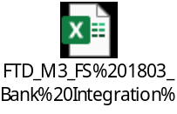 | H5 Script
Indonesia |  | H5 Script
Singapore |  | H5 Script
Vietnam | 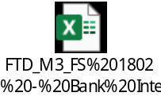 | H5 Script
China | 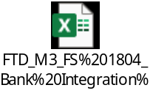 | H5 Script

APS130 Set banking method
Country | Document | Component
Malaysia | 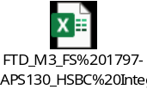 | H5 Script
Indonesia | 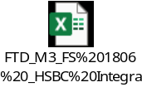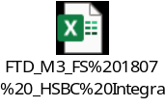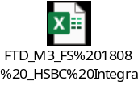 | H5 Script
Singapore | 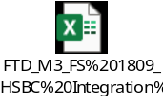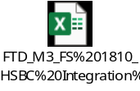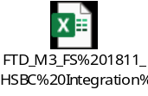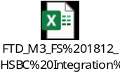 | H5 Script
Vietnam | 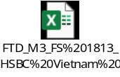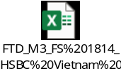 | H5 Script
China | 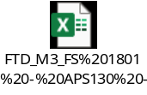 | H5 Script

Email notifications
Bank | Document | Component
HSBC | 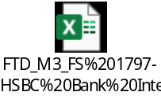 | H5 Script
SCB | 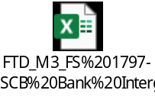 | H5 Script

Email group Definition

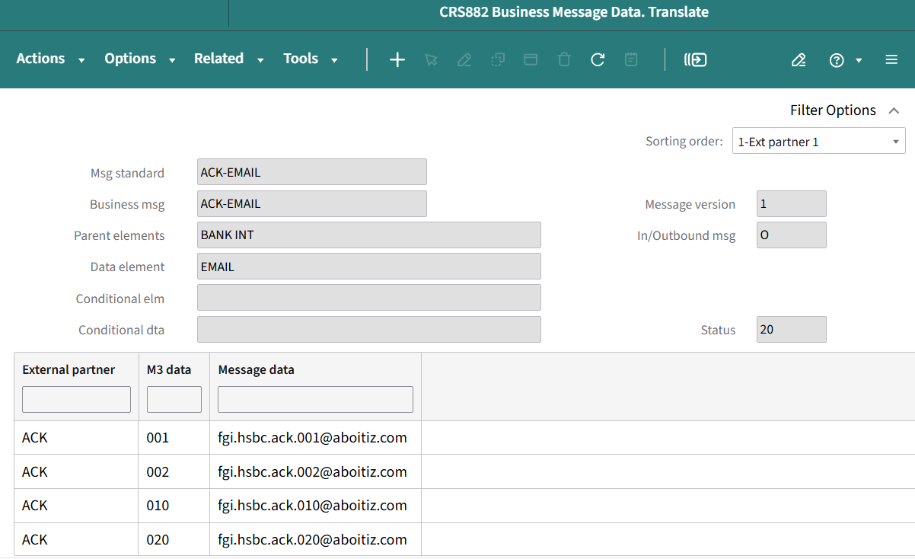

Defining User Roles

Role | Responsibilities
ION Administrator | Configure connection points, document flow, error management
EC Server Administrator | Maintain shared folder access and availability
Support Team (GC / Fortude) | Receive notifications, troubleshoot failures
Business Users | Process invoice and payments

    - Test cases and results

No | Test Case
1.0 | Generate banking XML for a Multiple invoice payment - HVP
1.1 | Generate banking XML for a Multiple invoice payment - LVP
1.2 | Generate banking XML for a Multiple invoice payment - Duitnow
1.3 | Generate banking XML for a Multiple invoice payment - HVP
1.4 | Generate banking XML for a Multiple invoice payment - LVP
1.5 | Generate banking XML for a Multiple invoice payment - Fast
1.6 | Generate banking XML for a Multiple invoice payment - HVP
1.7 | Generate banking XML for a Multiple invoice payment - LVP
1.8 | Generate banking XML for a Multiple invoice payment - PP
1.9 | Generate banking XML for a Multiple invoice payment - Fast
1.10 | Generate banking XML for a Multiple invoice payment - FTR
1.11 | Generate banking XML for a Multiple invoice payment - LTR
2.0 | Generate banking XML for a single invoice payment - ACH
2.1 | Generate banking XML for a single invoice payment - RTGS
2.2 | Generate banking XML for a single invoice payment - Book Transfer
2.3 | Generate banking XML for a single invoice payment - TT
3.1 | Validate email recipient group
3.2 | Validate email subject
3.3 | validate email body message
4.1 | Validate payment details in the email body table section: for Accepted payment proposals
4.2 | Validate payment details in the email body table section: for Rejected payment proposals
4.3 | Validate email footer: The ISO reason codes and details should be displayed in the footer section of the email
5.1 | Email should be received within reasonable time

Table 2Test Cases:

- Non-functional Specifications (NFRs)
The following non-functional requirements apply to the existing HSBC and SCB banking integration and the ISO 20022 enhancements described in this specification.

4.1 Data Validation and Compliance
- The solution must generate payment files in accordance with the applicable bank-specific XML and ISO 20022 requirements.
- For HSBC payments, the solution must comply with the ISO 20022 requirements defined in Section 3.2 of this specification.
- Debtor and Creditor postal addresses must contain the mandatory Town Name and Country information.
- SWIFT/BIC values must comply with the defined BIC format requirements before the payment file is transmitted to HSBC.
- Ustrd information must comply with the defined 105-character limit per <Ustrd> field.
- Invoice information must not be truncated or split between an invoice number and its corresponding invoice amount.
- Where multiple <Ustrd> fields are required, they must remain within the same <RmtInf> element.

4.2 Reliability and Availability
- The integration should process confirmed payment proposals without manual intervention under normal operating conditions.
- The existing MEC, EC Server, PowerShell and bank connectivity components must remain available to support the end-to-end payment process.
- Failed file transfers must be logged and support the existing retry/reprocessing mechanism.
- Bank acknowledgment files must be processed without impacting subsequent payment processing.

4.3 Security
- Payment files must be transferred to the banks using the existing secured communication mechanism.
- Bank credentials and connection details must not be stored in plain text within scripts or configuration files.
- Access to payment files, EC Server folders, MEC configurations and integration components must be restricted to authorized users.
- Outbound and inbound payment files must be protected against unauthorized modification or deletion.

4.4 Auditability and Traceability
- Payment processing must remain traceable from the M3 payment proposal through to the outbound XML file and bank acknowledgment.
- The system must retain sufficient information to identify the payment proposal, payment file, transfer status and bank acknowledgment.
- ISO 20022 validation failures must be identifiable during troubleshooting.
- Existing logging and monitoring mechanisms must continue to operate following implementation of the ISO 20022 changes.

4.5 Maintainability and Supportability
- ISO 20022-specific validation and mapping changes should be implemented in a manner that minimizes impact to the existing country/bank integrations.
- Country-specific requirements must remain clearly identifiable within the integration configuration.
- Any future changes to HSBC ISO 20022 requirements should be implementable without redesigning the complete payment integration.
- Technical documentation and configuration must be maintained to support future troubleshooting and enhancements.

- Assumptions and Dependencies

5.1 Assumptions
- The existing M3 → MBM 500 → MEC → EC Server → Bank integration architecture will remain unchanged.
- The ISO 20022 changes described in this specification apply to the existing HSBC integration only. The existing SCB China integration is not changed as part of these requirements unless separately specified.
- Existing payment proposal, payment confirmation, MBM generation, file transfer and acknowledgment processes will continue to operate as currently designed.
- The required Debtor and Creditor address information, including Town Name and Country, is available from the relevant M3 master or transaction data.
- Existing supplier/customer master data will be maintained by the business. The integration will validate and consume the available data rather than introduce a new master-data maintenance process.
- Valid SWIFT/BIC information will be maintained in the applicable banking master data.
- Invoice numbers and invoice amounts required for Ustrd generation will be available to the payment file generation process.
- Where multiple invoices are included in a payment, the invoice number and corresponding invoice amount will be available as complete values so that they can be maintained together when creating multiple <Ustrd> fields.
- The HSBC ISO 20022 requirements provided for this enhancement remain applicable to the relevant payment types and countries.
- The business will provide confirmation of any country-specific purpose-code requirements, where applicable.

5.2 Dependencies
The solution is dependent on:
- Infor M3 availability and successful payment proposal processing.
- Correct supplier and banking master data.
- APS161PF generation following payment confirmation.
- Successful generation of MBM 500.
- MEC availability and correct XML mapping configuration.
- Availability of the EC Server outbound and inbound directories.
- Availability of the PowerShell-based secure file transfer process.
- HSBC bank connectivity and acceptance of the generated XML file.
- Availability of HSBC acknowledgment files.
- ION and IDM services for downstream notification and document distribution.
- Correct configuration of ISO 20022 XML mappings and validations.
- Availability of the required address, BIC and invoice/remittance information in the source data.
Any change to HSBC's ISO 20022 specifications, XML schema, validation rules, field lengths or mandatory data requirements may require a corresponding update to the solution.

- Environment
The ISO 20022 changes will be implemented within the existing banking integration environments.

6.1 Test Environment
The following components will be used for development and testing:
Component | Environment / Purpose
Infor M3 | TST – Payment proposal and payment confirmation
APS100 / APS130 / APS131 | TST – Payment processing and banking method selection
APS161PF | TST – Payment confirmation trigger
MBM 500 | TST – Integration trigger
MEC | TST – XML transformation and validation
EC Server | TST – Outbound/inbound file handling
PowerShell | TST – Secure file transfer
HSBC | HSBC test/host connectivity as applicable
ION | TST – Workflow and notification
IDM | TST – Document storage/distribution

6.2 Production Environment
Following successful testing and business/UAT approval, the changes will be deployed to the existing Production environment.
The Production implementation must use the existing:
M3 → MBM 500 → MEC → EC Server → PowerShell → HSBC
flow.
No new external payment processing platform or manual bank portal upload is introduced as part of this enhancement.

- Additional Information

7.1 ISO 20022 Regulatory/Bank Requirement
The ISO 20022 changes documented in this specification are based on the HSBC requirements provided for the existing HSBC payment integration.
HSBC has advised that Town Name and Country are required for Priority Payments, with structured or hybrid address formats becoming mandatory from November 2026. After November 2026, HSBC will only process Priority Payment instructions using either a structured or hybrid address format.

7.2 Impact on Existing Integration
The ISO 20022 enhancement does not replace the existing HSBC payment integration.
The following existing processes remain unchanged:
- Supplier invoice creation.
- Payment proposal creation.
- Banking method selection.
- Payment confirmation.
- APS161PF generation.
- MBM 500 generation.
- MEC processing.
- XML file creation.
- EC Server file handling.
- Secure file transfer.
- Bank acknowledgment processing.
- ION workflow.
- IDM document handling and email notification.
The changes are limited to the data validation, XML mapping and formatting requirements necessary for HSBC ISO 20022 compliance. The existing integration already performs country and bank-specific XML transformation through MEC.

7.3 ISO 20022 Data Requirements
The following areas have been identified as requiring attention:
Area | ISO 20022 Requirement
Debtor Address | Town Name and Country must be populated
Creditor Address | Town Name and Country must be populated
Address Format | Structured/Hybrid format as applicable
SWIFT/BIC | Must comply with the defined BIC format
Ustrd | Maximum 105 characters per <Ustrd> field
Multiple Invoices | Invoice number and amount must remain together
Multiple Ustrd | Additional <Ustrd> elements to be used within the same <RmtInf>
Continuation | + indicator to be used where applicable
XML | Must comply with HSBC ISO 20022 requirements

7.4 Reference Documentation
The HSBC ISO 20022 address requirements should be retained as the reference for the address-related changes. HSBC specifically recommends that ERP/TMS providers review the data supplied in payment instructions and make the necessary updates ahead of the mandatory requirements.

7.5 Support and Future Changes
Any future changes communicated by HSBC relating to ISO 20022, including:
- mandatory fields,
- address structure,
- field lengths,
- validation rules,
- XML schema changes,
- BIC/SWIFT validation,
- remittance information requirements, or
- country-specific regulatory requirements,
must be assessed and, where applicable, incorporated into the HSBC integration specification and associated MEC mappings.

